Password Resetting Design

Database:

We need a new table to storage the important things like the auto-generated code.

**Table name:** Reset

**Description:** This table mainly records the temporary message while a customer wants to change his/her password. The kernel is to control the time and the tab.

|  |  |  |
| --- | --- | --- |
| Column | Type | Description |
| Number | int | Auto increment by 1 unique  starts from 1 |
| Email | text | Record the code was sent to which email |
| Code | int | Auto, randomly generated  usually 6 digits, |
| State | boolean | True: allow user to modify the passwd  False: not allow |

**Node**: The trigger might be damaged to the project so there is no trigger in our project. We should find another way to deal with delayed update functions on State.

Flow:

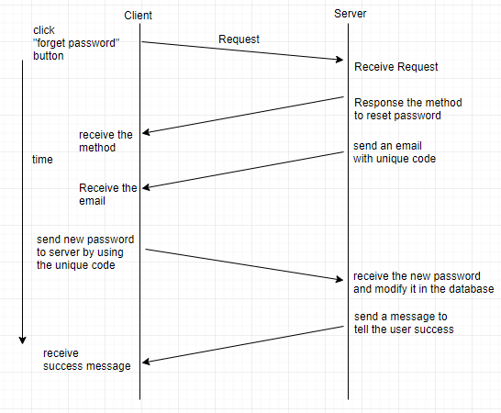

Or the flow chart

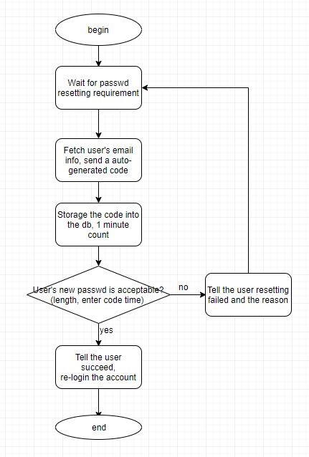

Examples for code:

Front end:

When user types reset the code, using Ajax or something like that to keep users at present page.

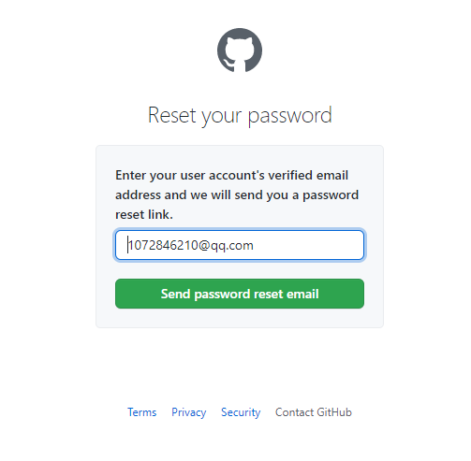

Fig 1. Github resetting password

Ajax in JQuery(Sorry I haven’t used other ways, it’s just a reference)

ajax({

url:"EmailSending",

method:"get",

data:"email="+$email,

success:function(result,testStatus){ //pass the email to the backend

if(result == "true"){

alert("have sent a code to your email");

}else{

alert("please register at first");

},

error:function(xhr,errorMessage,e){

alert("404 error")

}

});

Back end:

@GetMapping(value = "EmailSending ")

@ResponseBody

Public boolean EmailSend(@RequestParam(value="email",required = true) String email){

/**

* 1. Judge if the email is in the table Users. If no, return false

* 2. using auto generating tools to generate a 6 digits code, then sql: insert into Reset(Email, Code, State) values(email, code, true);

* 3. Send a email to the user(using email tools and might add some dependencies)

* 4. Startup another thread and count 60s, the sql: update Reset set State = false where Email = email;

* 5. Return true to the front end.

*/

}

Then the password resetting part.

The procedure is almost the same as EmailSending. The most important thing is sql:

Select exists (select 1 from Reset where Code = $(front send code) and State = true and Email = $(front send email));

If the result is true, then modify it.